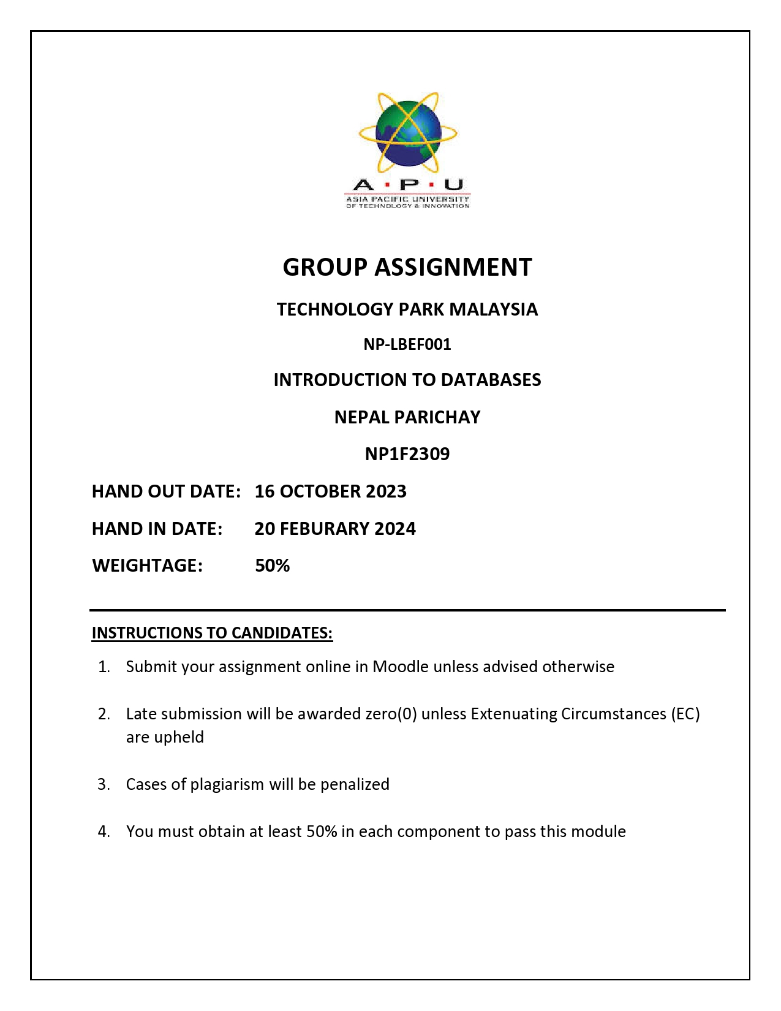

# **C:\Users\dhita\Videos\Frame 4.png**

Table of Contents

2

**Introduction** 3

**1.2 Some facts about Dhulikhel** 3

**2. Destination Overview of Dhulikhel** 4

**3. Dhulikhel’s Tourism Assets** 4

**3.1. Dhulikhel Tourism Landscape** 4

**3.2. Adventure tourism** 5

**3.3 . Agriculture tourism** 5

**3.4 Tangible and Intangible Heritage** 6

**3.5 Tourist accommodation** 6

**4. Economic Activities** 7

**4.1 Major Economic Activities in Dhulikhel** 7

**4.1.1 Agriculture** 7

**4.1.2 Forestry** 7

**4.1.3 Trade and Business** 7

**4.1.4 Transportation and Logistics** 8

**4.1.5 Tourism** 8

**5. Economic Impact** 8

**6. Major issue** 9

**7. Intervention/Strategies** 10

**7.1 Heritage** 10

**7.2 Tourism for Adventure** 11

**7.3 Tourist Facilities** 11

**8. Recommendations and Action Plan** 11

**Conclusion:** 12

# 

# **Introduction**

Dhulikhel is one of Nepal’s oldest cities and a popular tourist attraction in the country. It is in the district of Kavrepalanchowk, at the eastern end of Kathmandu Valley. Dhulikhel is an important historical trading town on the primary trade route connecting Nepal and Tibet, with a rich cultural history, breathtaking vistas of Mount Everest, and a lively diversity. Dhulikhel is currently connected to two highways, the B.P. Highway and the Araniko Highway, which connects Kodari, a Tibetan border town with Kathmandu, Nepal’s capital.

Dhulikhel, like the rest of the world, recognizes the great allure of the tourism industry. Recognizing its economic benefits, tourism serves as a channel for the transfer of resources from industrialized to developing countries. This business is a key source of hard currency and jobs, especially in a developing city like Dhulikhel, which has a high unemployment rate. Tourism, in addition to producing jobs, serves as a regional policy tool, promoting equitable resource allocation. Furthermore, in our ever-changing global environment, it helps significantly to political and social understanding by encouraging cross-cultural dialogue and international collaboration.

Dhulikhel, located in the heart of Nepal, exemplifies the country’s incredible diversity. It is surrounded by the magnificent Himalayas and gives a breathtaking view of snow-capped peaks. Dhulikhel has a vibrant local culture as well as a rich cultural history of the historic Newar settlement. It serves as a gateway to some of Nepal’s most well-known attractions, including Mt. Gaurishankar, Mt. Lhotse, Mt. Dhaulagiri and artistic temples of the town. The region’s distinctive flora and fauna, cultural tapestry, and ease of living all add to the region’s popularity as a tourist destination.

Despite being one of the most significant economic sectors in Dhulikhel, tourism is underappreciated. There are many opportunities to increase tourism in Dhulikhel. For instance, by putting on thoughtfully planned events that emphasize the significance of this outstanding cultural asset but due to the lack of proper leadership, proper plans and their implementation, the issue is yet to be addressed.

## **1.2 Some facts about Dhulikhel**

Area: 54.62 sq.km.

Area of Community Forests: 8.53 sq.km.

Total Number of Community Forests: 36

Altitude: 1550 m (5,085.3 ft).

Total Wards: 12 Ward

Density of population: 582 Average

Total Population: 37000

Household’s size: 4.5

Growth rate of population: 0.65

No of Households: 7040

Climate in the City

Climate: Subtropical

Minimum: 0 degree Celsius

Maximum: 35 degree Celsius

Average (Yearly): 1500mm

# **2. Destination Overview of Dhulikhel**

Dhulikhel lies around 30 km east of Kathmandu, on the path to Tibet. It is frequented by local tourists as a day or weekend excursion from Kathmandu, as well as international tourists as a day trip or on their route from Kathmandu to the Chinese border. Dhulikhel is known for its stunning mountain views and ancient temples and monuments with cultural richness. Although the city is sometimes packed with locals and both national as well as international visitors and tourists, it provides a peaceful retreat.

## **3. Dhulikhel’s Tourism Assets**

Dhulikhel’s cultural and tourism assets provide a snapshot of important tourism attractions, the obstacles associated with their development, sustainable management, and potential to further enhance assets or overcome growth constraints. Tourism assets include distinct destinations in its own right that rely largely on geography, experiences, or human capital, as well as physical infrastructure that facilitates tourist transportation and visitor experience.

### **3.1. Dhulikhel Tourism Landscape**

Dhulikhel, located in the foothills of the Kathmandu Valley, is one of the most famous places in Nepal for viewing stunning Himalaya views. In clear weather, snow-capped peaks of the Himalayan ranges from Mount Langtang (7,234m) in the west to Mount Everest (8,848m) in the east can be seen. Mount Annapurna (8,091m), Mount Ganesh (7,429m), Mount Phuribichyachu (6,637m), Mount Gaurishankar (7,134m), Mount Lhotse (8,516m), and 15 more mountains may be seen from various parts of the city. Long views of agricultural land, including terraced rice fields and wooded regions, provide excellent chances for sight-seeing, particularly between October and March, when monsoon clouds lift to reveal panoramic views of beautiful mountain ranges.

## **3.2. Adventure tourism**

Dhulikhel is a popular hiking and trekking destination, as well as mountain riding and cycling due to its clean environment, beauty, and links to cultural places. Cycling and mountain riding, in particular, have the potential to expand in popularity. There are also several activities in the area, such as canyoning, bungee jumping, high rope, rafting, and bird viewing. These are the part of the adventurous tourism which contribute to the rising rate of tourism in Dhulikhel.

## 

## **3.3 . Agriculture tourism**

Agriculture is the most common land use in Dhulikhel due to which Dhulikhel has attracted agriculture-related value-added companies like cheese making with farm-gate retail and homestays.

**Homestay Programs in Dhulikhel**

“**3.3.1 Bhatte Danda Homestay:**   
Bhatte Danda homestay is the first homestay program started in Dhulikhel. It was started with the inauguration of Nepal Tourism Year 2011 (On 14th January 2011). It was established by joining hands of the people living in this community. It is also known as the Mahila Samuha Homestay (Women’s Community Homestay). The organic foods are provided to the tourists during their period of homestay. The Tamang culture can be observed in this homestay and the tourists can learn the lifestyle and tradition of the Tamang community during their stay. The homestay also organizes hiking and trekking in and around Dhulikhel.

**3.3.2 Phoolbari Homestay**:

Phoolbari Village is one of the villages located near Dhulikhel Municipality . Phoolbari, meaning garden in Nepali resembles the garden of different castes and cultures of the people living in the village. The village lies at an altitude of 1800m above sea level. It is about 1-hour drive from Dhulikhel. The homestay program has been successful for providing services to the Tourists due to the hospitality of the villagers. One can have both natural and cultural elements in this area. “

## **3.4 Tangible and Intangible Heritage**

Dhulikhel’s constructed fabric and continuous customs indicate a robust living legacy. Dhulikhel’s living heritage is both ‘intangible’ (cultural practices) and ‘tangible’ (physical). “Intangible” heritage is directly related to living cultures, the built environment, faith, customs, folklore, arts and handicrafts, music, and people’s daily lives. Dhulikhel is a melting pot of several communities, including Newars, Brahmins, Chhetris, Tamangs and Dalits, whose traditions illustrate Dhulikhel as strong living cultural heritage.

**3.4.1 Dhulikhel is blessed with many tangible built heritage assets including:**

Ward 5’s central “Old Town” area is distinguished by:

Two to four-story Newari-style residences with terracotta brick (both plain and decorative varieties), mud plaster, terracotta gabled roofs, open windows and intricately carved wooden doors and windows, window shutters, lattice windows, a variety of window styles, decorative door columns on the ground floor. Pagoda style temples, stone carved statues, shrines and hitis are found around the temples and within the streets and large central courtyards. Intimate scaled medieval stone paved streets. Other temples outside the old town include Shee Khandapur, Kali Temple, Gaukhureswor Mahadursthan and Hazaar Sindhi.

## **3.5 Tourist accommodation**

Dhulikhel has a diverse choice of accommodation options, and new accommodation premises are the Municipality’s fastest expanding business category. Accommodation options include budget hotels, luxury hotels, and rural homestays. The majority of lodging is concentrated in urban regions, and it is projected that this trend will continue. Dhulikhel has training colleges that teach students how to work in the hospitality industry which is a significant resource for delivering high-quality lodging.

Major Hotels and Lodges in Dhulikhel include:

1. Hotel Mount View Pty Ltd, Dhulikhel
2. **Gaia Holiday Home, Dhulikhel**
3. Hotel Gaurishanker Mountain View Pty Ltd, Dhulikhel
4. Dhulikhel Mountain Resort Kwawa, Dhulikhel Municipality
5. Himalayan Horizon Hotel Sun and Snow Pty Ltd, Dhulikhel
6. Dhulikhel Lodge Resort, Dhulikhel

# **4. Economic Activities**

Tourism revenue is expected to provide a growing part of Dhulikhel’s foreign exchange revenues based on current trends. The IUDP team’s fieldwork also revealed that many people work directly in hotels and restaurants, and tourism directly generates a large number of full-time jobs for locals.

As a result, the tourist industry has the potential to significantly enhance people’s living standards in Dhulikhel municipality by providing long-term job opportunities. However, earnings distribution into the Municipality’s rural sections remain unrealized. Economic growth that creates jobs, enhances the local tax base promotes environmental sustainability, social equity, and assists individuals in living better lives. But Dhulikhel Municipality is crucial to it.

## **4.1 Major Economic Activities in Dhulikhel**

The Municipality has several very evident factors, such as market closeness and environmental circumstances that provide a competitive edge for a variety of economic sectors, as follows:

### **4.1.1 Agriculture**

Agriculture is the region’s most important economic activity since it offers both a living and a source of employment. The majority of people are employed in the production of cash crops such as rice, maize, and vegetables. In 2070/2071, Dhulikhel Municipality produced 42,540 tons of agricultural products on 7586 hectares of land. Seasonal vegetables are cultivated year-round, while off-season vegetables are grown in irrigated greenhouses to provide markets in Dhulikhel, Bhaktapur, and Kathmandu. Cash crops such as mustard, sunflower, lentil, beans, and spices are also grown alongside vegetables. Fruit harvests are produced in the region , for sale in kathmandu but in small quantities.

### **4.1.2 Forestry**

There are Shorea robusta forest, Pinus roxburghe forest, and an intermediate zone of mixed forest in the hills of Dhulikhel zone. The sustainable utilization of forest resources such as medicinal plants and wood may produce significant economic value of thew forests in Dhulikhel Municipality.

### **4.1.3 Trade and Business**

Dhulikhel has a minor commercial sector known as Dhulikhel Bazar, which houses the major banking institutions and retail establishments and other various commercial centers.

### **4.1.4 Transportation and Logistics**

Two of the most major national roadways link Dhulikhel. The Araniko highway connects Nepal with China, while the B.P highway connects the mid-hills and the Terai. Dhulikhel serves as an important transportation and logistics center. Throughout the day, trucks stop at the bus stop adjacent to Sarathi Mart before returning to the roads at night. They transport building supplies such as sand and concrete from one area to another. Dhulikhel also serves as a major travel hub between Kathmandu and the Terai area.

### **4.1.5 Tourism**

Dhulikhel Municipality possesses natural, cultural, and religious attractions which has resulted in the establishment of a thriving tourism sector. The Municipality caters to domestic and international tourists by providing conference facilities and promoting education and health tourism through the Kathmandu University, Kathmandu University Hospital, and other government services.

# **5. Economic Impact**

According to the IUDP team’s field survey, tourism directly provides a huge number of full- time employment for local inhabitants, with many individuals employed directly in hotels and restaurants.

Tourism also has an economic impact. For instance, income from different supplementary services for guests, such as arts and crafts production, primary producers, and so on. The tourism industry has the ability to significantly improve circumstances in the municipality.

However, the revenue sharing amongst municipal regions has not yet been implemented. Municipalities help the economy by lowering municipal taxes on firms and industries with 25 or more employees.

# **6. Major issue**

The major tourism development issues of Dhulikhel city can be identified as follows:

1. Hotel accommodation and tourist attractions are concentrated only in and around the bazaar area, and there are not enough tourist and leisure facilities outside the city center or near major tourist attractions to meet the needs of tourists.

2. Most rural and emerging areas have great potential but remain underutilized for tourism.

3. There is a critical need to safeguard and efficiently manage the development of major historical and landscape values within the municipality, which is located distant from the city core.

4. To optimize tourist experiences of intangible and tangible heritage, a more integrated strategy is required.

5. Access to tourist destinations and activities is limited due to poor direction and a lack of adequate, high-quality signage.

6. A lack of direction and adequate, high-quality signage restricts access to 4,444 tourism sites and experiences.

7. Dhulikhel’s lack of branding and internet advertising as a tourist destination, including locations, features, culture, and festivals.

# **7. Intervention/Strategies**

Taking into account the potential and constraints in Dhulikhel Municipality, the conservation, culture, and tourist development plan is based on six primary tourist objectives which are as follows:

1. Utilization of Dhulikhel’s historical, social and architectural heritage.

2. Utilization of the municipality’s natural and scenic attractions.

3. Utilization of agricultural land for agrotourism.

4. Maximization of nature-based adventure tourism

5. Municipality-wide Expansion and improvement of the range of tourist accommodation in

6. Improvement and maintenance of tourism infrastructure.

7. Coordinate human resources activities to engage with the tourism industry, including

marketing, and ensure action is taken.

Specific measures are taken to support these goals. Few of them are following:

## **7.1 Heritage**

1. Developing a heritage strategy to prioritize the heritage efforts.

2. Building on the Heritage Survey prepared by the Technical University of Berlin and Kathmandu University, formally protect and preserve the significant heritage sites identified in Districts 5, 6 and 7 through Land Use Zones and Ordinances.

3. Establishing historic preservation guidelines to help community staff and property owners make decisions about historic buildings based on best practices.

4. Establishing a Heritage Advisory Committee to support heritage decision-making.

5. Establishing a heritage walk in the Old City of District 5.

6. Promote the cultural festival in Dhulikhel and increase the number of visitors.

7. Work with local communities to develop a high-quality, accessible museum to properly archive, display and promote the heritage that is important to Dhulikhel.

## **7.2 Tourism for Adventure**

To optimize nature-based adventure tourism, construct and connect new and existing walking routes to create a series of new treks.

1. Create or link a network of bike paths, both on and off the road.

2. Conduct a feasibility study for the development of adventure tourism components such as bungee jumping, rope walks, and a cycling path to a waterfall at Devitar.

## **7.3 Tourist Facilities**

Municipalities should encourage the development of tourist accommodation by enacting active planning policies, by-laws, and land zoning to assist the building of such facilities in order to grow and improve the provision of tourist accommodation throughout the municipality. Outside of the city center, 4,444 tourist attractions are accessible to persons of all abilities.

The duties of the Tourism and Promoting Advancement Officer are:

1. To manage programs to advance tourism within the region.

2. To work with town planning/building to advocate for the improvement of visitor foundations.

3.To co-ordinate the showcasing of tourism.

4. To back the Dhulikhel Natural and Tourism Advancement Committee.

# **8. Recommendations and Action Plan**

Dhulikhel has historically been an important natural and cultural center in Nepal. Dhulikhel, which is rich in cultural, architectural, and historical landmarks and located in a world-class scenery, has suffered from a lack of promotion to attract tourists, and possibilities to celebrate are underutilized. Local communities, particularly underprivileged populations, can be more meaningfully engaged in tourism. There is scope for concurrent infrastructure development, business mentorship, increase in accommodation, protection, and management.

The Plan consists of a range of Destinations and Actions. It Comprises:

1. Tourism Development Plan

2. List of Future Tourism Places

3. Potential Religious tours/trekking/cycling routes

4. Implementation Action Plan

# **Conclusion:**

Dhulikhel’s blend of culture and tourism has resulted in financial prospering while safeguarding its wealthy past. This beneficial connection attracts visitors, generating revenue for local companies and contributing to community betterment. The town’s commitment ensures the authenticity of its social personality, promoting a unique encounter for tourists. In any event, it is critical to maintain a delicate balance in order to avoid over-commercialization. Dhulikhel’s an example of how the merge of culture and tourism has not only safeguarded tradition but also supported long-term financial prosperity.